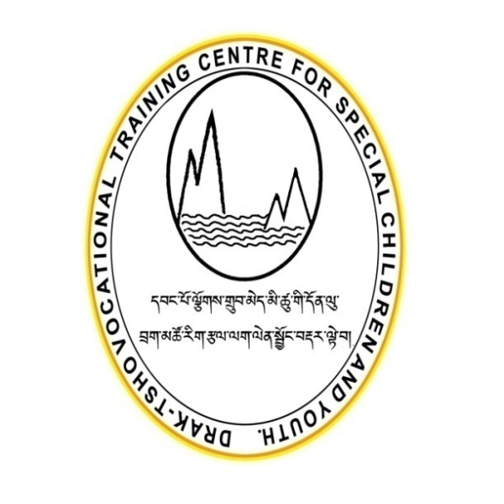
DRAKTSHO VOCATIONAL TRAINING CENTRE FOR SPECIAL CHILDREN AND YOUTH

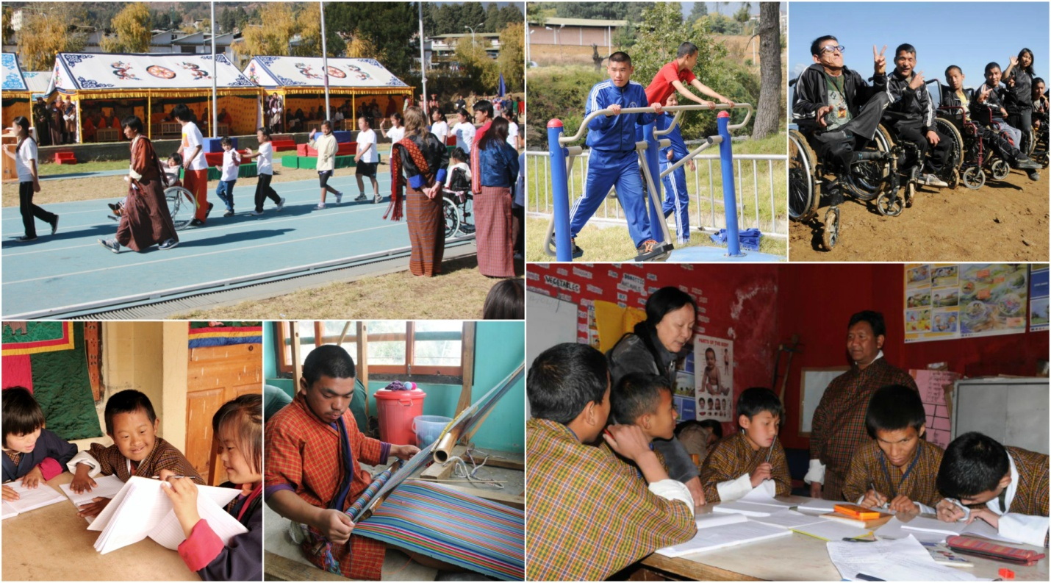

Draktsho Annual Report 2017

Table of Contents

- Foreword...........................................................................................................
- Programs and Activities...................................................................................
- World Down Syndrome Day...........................................................................
- World Autism Day............................................................................................
- Foundation Day................................................................................................
- Celebration of International Day of Persons with Disabilities .................
- Success Stories .................................................................................................
- Challenges .......................................................................................................
- Our Pledged Donors ......................................................................................
- Partners ...........................................................................................................
- Financial Report ..............................................................................................
- Audit Report ....................................................................................................

Foreword
The aim of vocational education is to provide age-appropriate training support to change the substantial limitations in present functioning by identifying suitable training for youth with various types of disabilities and providing intensive training for the highly capable youth and rehabilitation type of training for the moderate and severely handicapped youth so that they may receive reasonable remuneration and a promising better quality of life.
Our focus has been on providing vocational training to students with various types of disabilities; however, this is not an easy task as there is not enough money to provide a wide range of services. There are many children who need special equipments for training which are very expensive. We need to include more training for intellectually challenged youth which require adequate space, equipments and more staff. There are children who are unprotected and disowned by families; these children need protection, education, a safe and caring place to live. Draktsho has been picking up many such children who have undergone unimaginable traumas and disadvantages of life.
Life they say is a blessing but for some it seems so unfair and cruel. Whatever it maybe I feel it is every body’s responsibility to see that every child is protected, is receiving education, training and equal opportunities. Draktsho is trying very hard to reach our services to all those who need them. In doing so, we have few generous members contributing to fulfill our cause and goals.
Draktsho is extremely grateful to all our pledged donors, sponsors and partners for the great contribution. Your contribution has lifted much stress and helped us concentrate on the development of all our students. You all have selflessly committed to join us in making a better life for our children and youth.
Draktsho is so lucky to have you supporting us and being part of our family.
Good luck and thank you

Rigzin Padma Tsogyal

Founder/Director
Draktsho

DRAKTSHO

Drak-Tsho is currently the only parent initiated vocational training program in Bhutan that specifically targets children and young people who have a disability. Drak-Tsho is the first of its kind in the country; it’s a service- oriented and non-profit making centre which aspires to enhance the living standard of children and youth with disability through empowerment by training, education and eventual integration with the mainstream population. Its main focus is to equip the trainees with vocational training skills to enhance their opportunities for gainful employment. It also aims to build their self-esteem and self-reliance, thereby making them more independent, confident and contributing members of the society. The Centres (Thimphu & Kanlung, Tashigang) encompasses opportunities that allow them to grow in their aptitude, determination, goals and dreams. One of the greatest challenges for the centre is to erase the deeply embedded stigma.
The management staff of the Drak-Tsho promotes the recommendations recorded in the 2007 ‘Master Plan’. There have been a lot of activities at the Centre like the development of written curricula for life skills which would provide not only identifiable guidelines for the staff and students, but also a means of providing the basis for evaluation of the program and the progress of students. Lot of awareness raising programs have also been organized.
The first branch of Drak-Tsho, based in Kanglung, Tashigang caters the same kind of services that are taught at Thimphu Centre. Plans for including more traditional based training and conventional based training are being developed to engage every student.

Our main objectives are:
- To provide training in life skills including basic literacy and numeracy to persons with special needs for enabling them to cope with their daily life needs in present and future.
- To equip trainees with special needs with vocational and work skills as preparation for sheltered, open or self-employment.
- To facilitate the trainees with special needs secure work with dignity.
- To initiate dialogue, build collaborations and networks with different stakeholders (government, industry, institutions etc) for actively promoting equal opportunities for people with special needs.
- To organize parent support and community outreach program for raising awareness and generating support for inclusion of persons with special needs.
- To conduct training, research and documentation for building human resources, supporting innovative actions and generating resource material and data for supporting quality services and advocacy.

While providing services and special education to children and youth with disabilities, Draktsho assures that all the International Days for people with Disabilities are celebrated. The first Day of celebration starts with the World Down Syndrome Day.
World Down Syndrome Day
Down Syndrome is a genetic occurrence caused by extra material in chromosome 21 that results in intellectual disability. It is not yet know why this occurs. The estimated incidence of Down Syndrome is between 1 in 1,000 to 1 in 1,100 live births worldwide. Each year approximately 3,000 to 5,000 children are born with this chromosome disorder and it is believed there are about 250,000 families in the United States of America who are affected by Down Syndrome.
In December 2011, the General Assembly declared 21st March as World Down Syndrome Day (A/RES/66/149). The General Assembly decided, with effect from 2012, to observe World Down Syndrome Day on 21st March each year, and invites all Member States, relevant organizations of the United Nations system and other international organizations, as well as civil society, including non-governmental organizations and the private sector, to observe World Down Syndrome Day in an appropriate manner, in order to raise public awareness of Down syndrome.
Draktsho also joins all nations to observe the World Down Syndrome Day on 21st March, 2017 at Draktsho centre. Students, parents, teachers and volunteers came together to raise awareness on Down Syndrome through cultural programs by the students.
Students and teachers of Draktsho East went to Kanglung Primary School in Tashigang where they conducted a awareness program on Down Syndrome. The group then continued to celebrate the day at Draktsho East Centre with fun games and cultural programs.
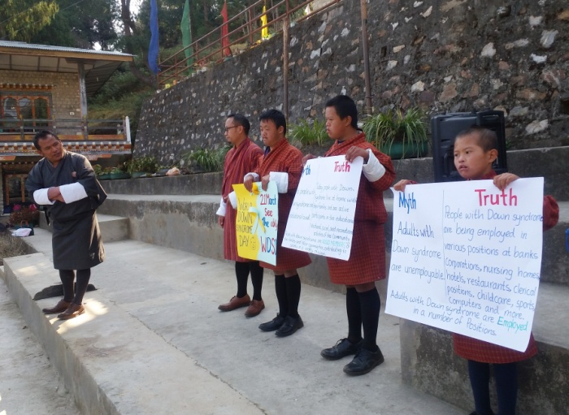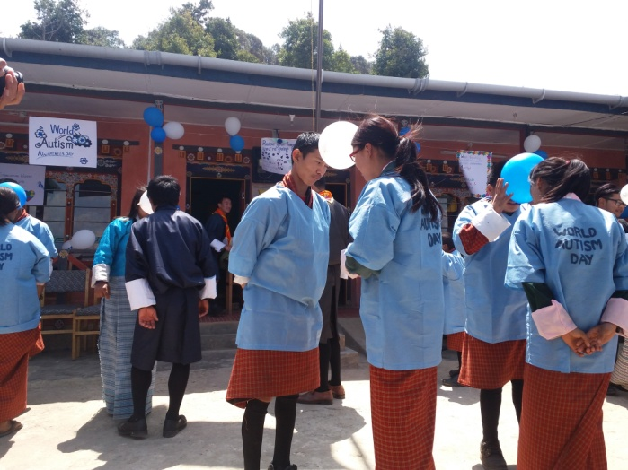

World Autism Awareness Day
World Autism Awareness Day is an internationally recognized day on 2nd April every year, encouraging Member States of the United Nations to take measures to raise awareness about people with autism throughout the world. It was designated by the United Nations General Assembly resolution "62/139. World Autism Awareness Day", passed in council on 1 November 2007, and adopted on 18 December 2007. It was proposed by the United Nations representative from Qatar, Her Highness Sheikha Mozah Bint Nasser Al-Missned, Consort of His Highness Sheikh Hamad Bin Khalifa Al-Thani, the Emir of the State of Qatar, and supported by all member states.
This resolution was passed and adopted without a vote in the UN General Assembly, mainly as a supplement to previous UN initiatives to improve human rights. World Autism Day is one of only four official health-specific UN Days. The day itself brings individual autism organizations together all around the world to aid in things like research, diagnoses, treatment, and overall acceptance for those affected by this developmental disorder.
On 2nd April Draktsho joined by other organizations working in the field of disability worldwide to celebrate the World Autism Awareness Day following the 2017 theme" Toward Autonomy and Self-Determination". Teachers, parents, volunteers and students gathered at Draktsho Centre to celebrate this special occasion to demonstrate their skills, experience, joy and participate in sharing of gifts, personal skills with their friends and families through various cultural programs, awareness and fun games. Draktsho East Centre collaborated with Sherubtse Community Based Scout at the centre itself to raise awareness about Autism. Both centres of Draktsho commemorated the day in Tashigang and Thimphu.
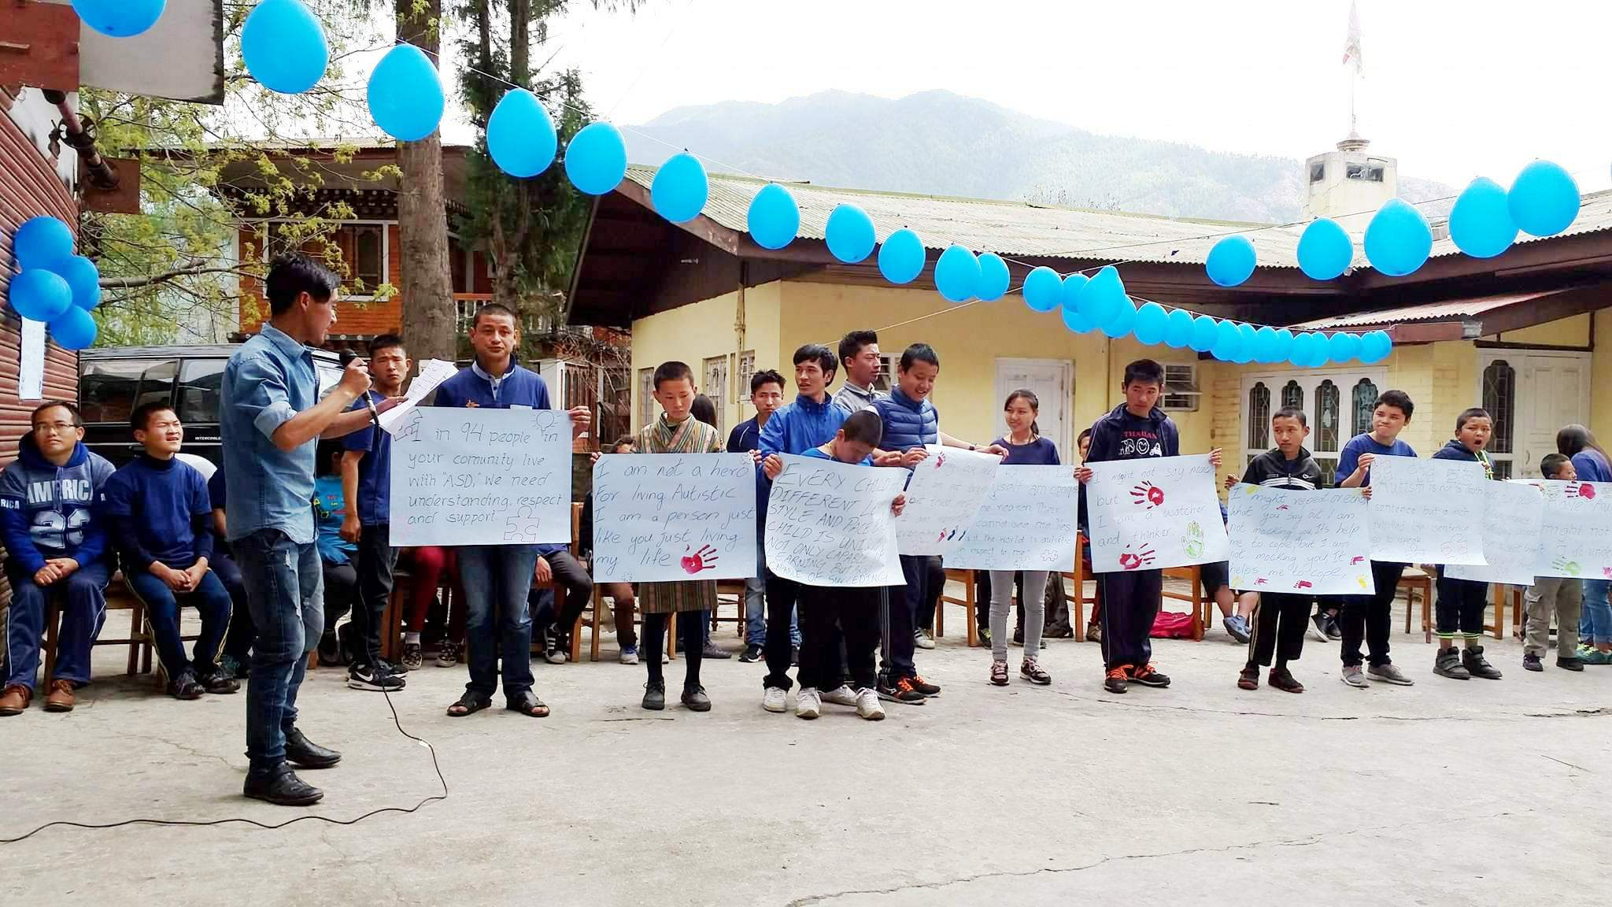

Athlete Leadership Program
The Athlete Leadership Program was initiated in 2016, the teachers of Draktsho have been training the students to enhance leadership qualities. The ALP focuses on training selected athlete leaders to gain confidence in building personal qualities to be leaders. They are specifically taught to be able to give speeches in public, give presentations, be able to assist teachers in organizing events and programs and managing fellow athletes. From our program we have appointed 5 athletes as leaders as they have the overall quality of becoming leaders.
On 10th August 2017, the athlete leaders of Draktsho Thimphu conducted a sports training program for their fellow students without the help of the teachers. This ALP is a program under the Special Olympics and as Special Olympics Bhutan operates under the umbrella of Draktsho all Special Olympic related events are conducted by Draktsho.
The leaders are Pelden, Bikask Subba, Leki Lhaden, Arjun Kumar Rai and Parina Rai.
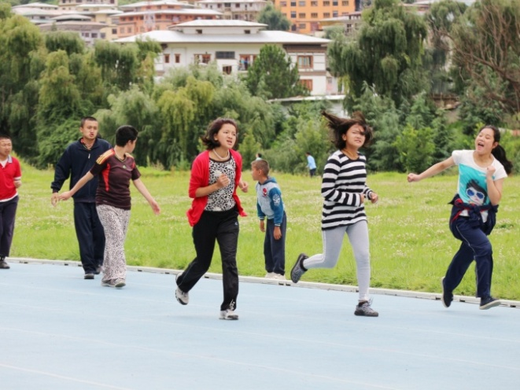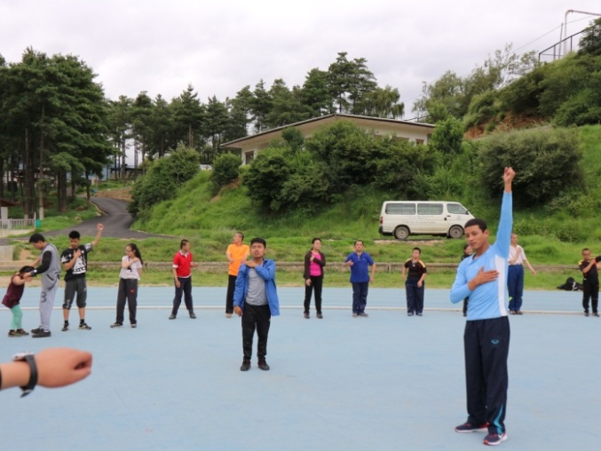
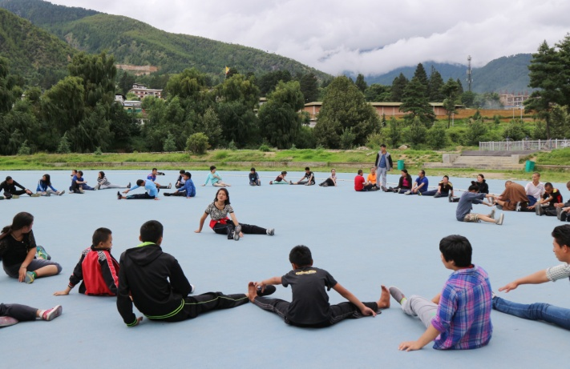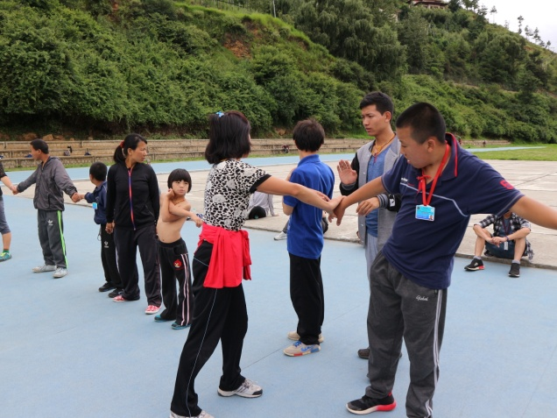
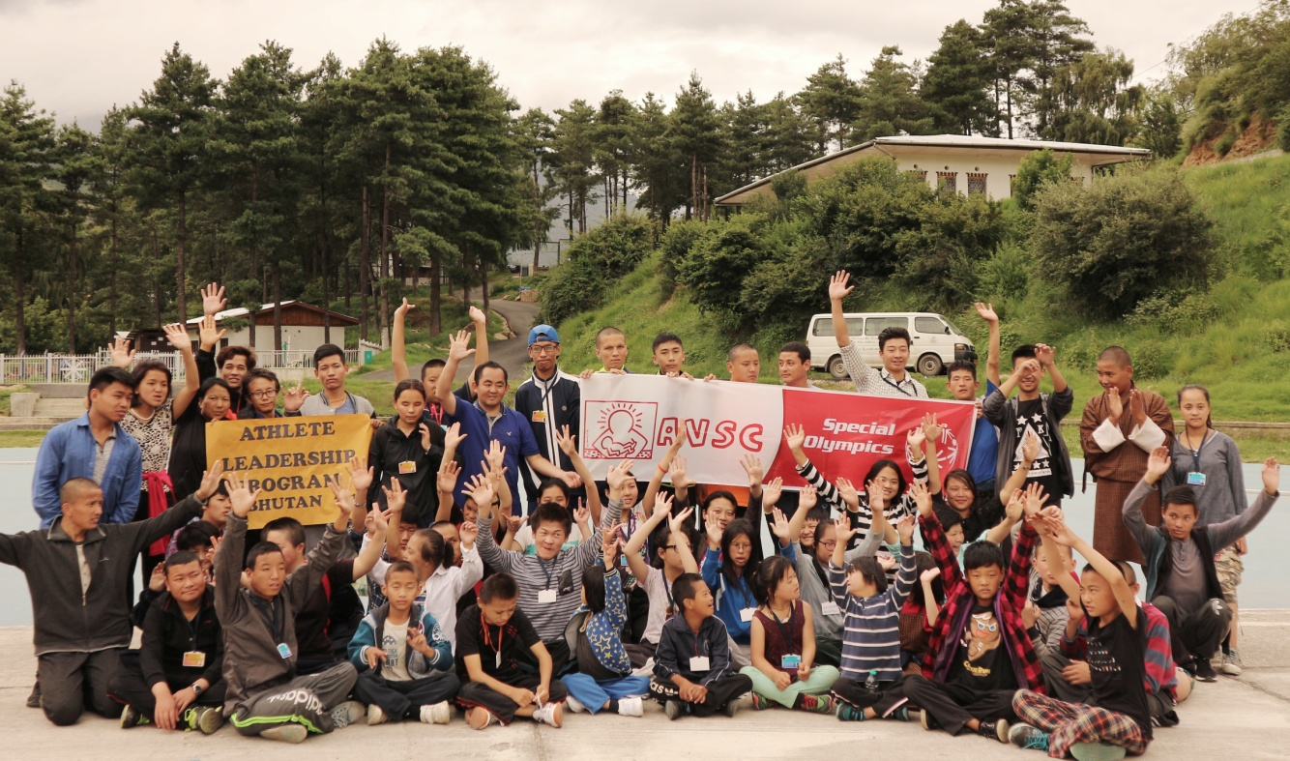

Foundation Day Draktsho marked its 17th years of establishment on 2nd October 2017. All the teachers, parents, students, volunteers and relatives celebrated the day at Namseling area. Draktsho family had a picnic on this Day. On this day every student is made to perform his/her dancing, singing or acting talents.
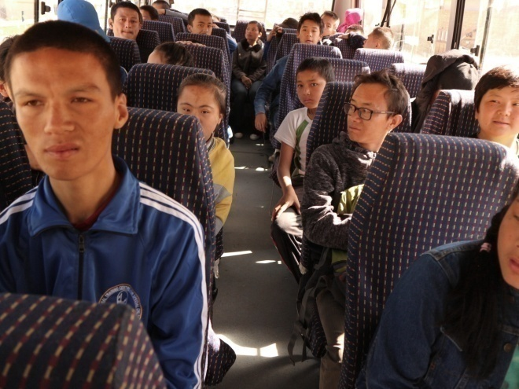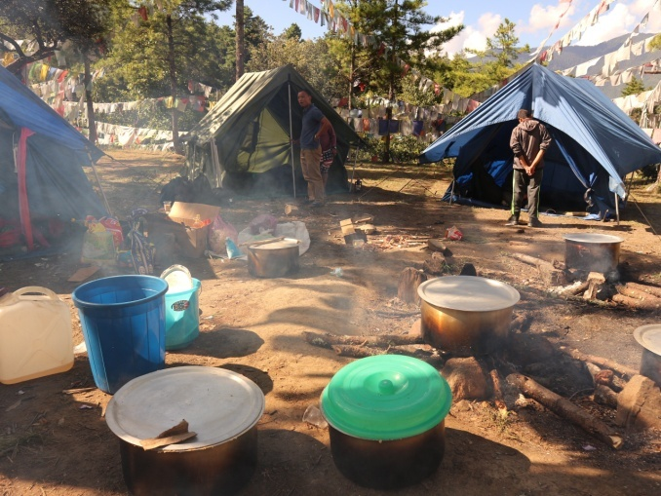
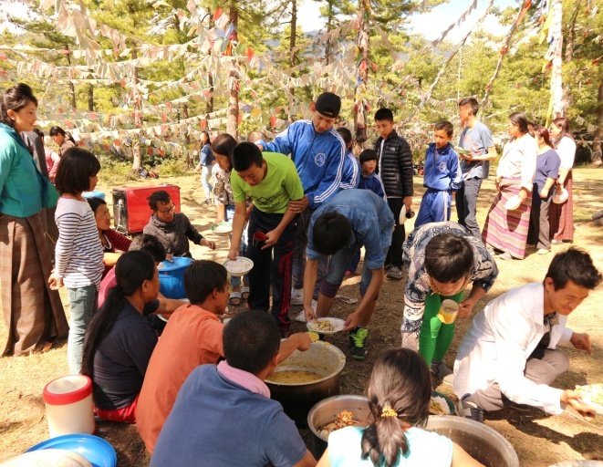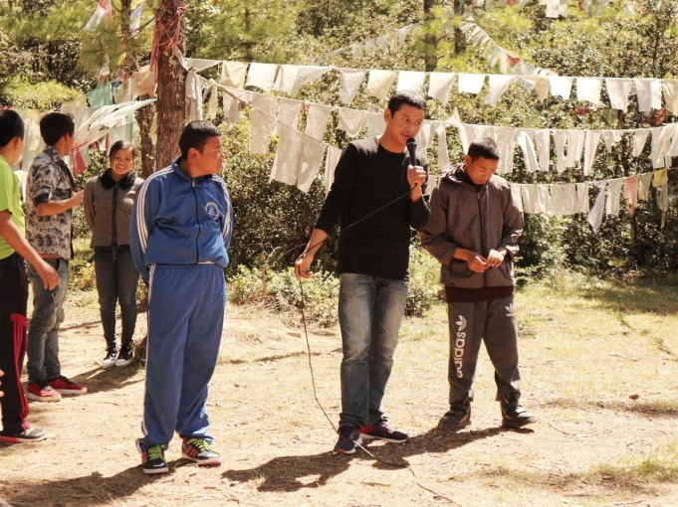

Celebration of International Day of Persons with Disabilities
Each year the UN announces a theme to observe for International Day of People with Disability. The annual theme provides an overarching focus on how society can strive for inclusivity through the removal of physical, technological and attitudinal barriers for people with disability. This has been occurring since 1992 when the General Assembly proclaimed 3rd December as the International Day of Persons with Disabilities. The theme for 2017 International Day of People with Disability is “Transformation towards sustainable and resilient society for all”. The overarching principle of this theme is to ‘leave no one behind’ and empowers people with disability to be active contributors of society
Draktsho celebrated the day on 3rd December involving students to equally participate in a sports competition to showcase their abilities and talents through the medium of sports. As sport is one of the core activities of Draktsho's curriculum the students undergo training in sports once every week. They practice Special Olympic type of sports which keeps them fit, healthy, share joy and happiness while moving towards an inclusive society. About 100 students participated in the sports competition that was organized on 3rd December at the Athletic Ground. Hon'ble Representative of UNDP Gerald Daly graced the occasion as the Chief Guests of the event.
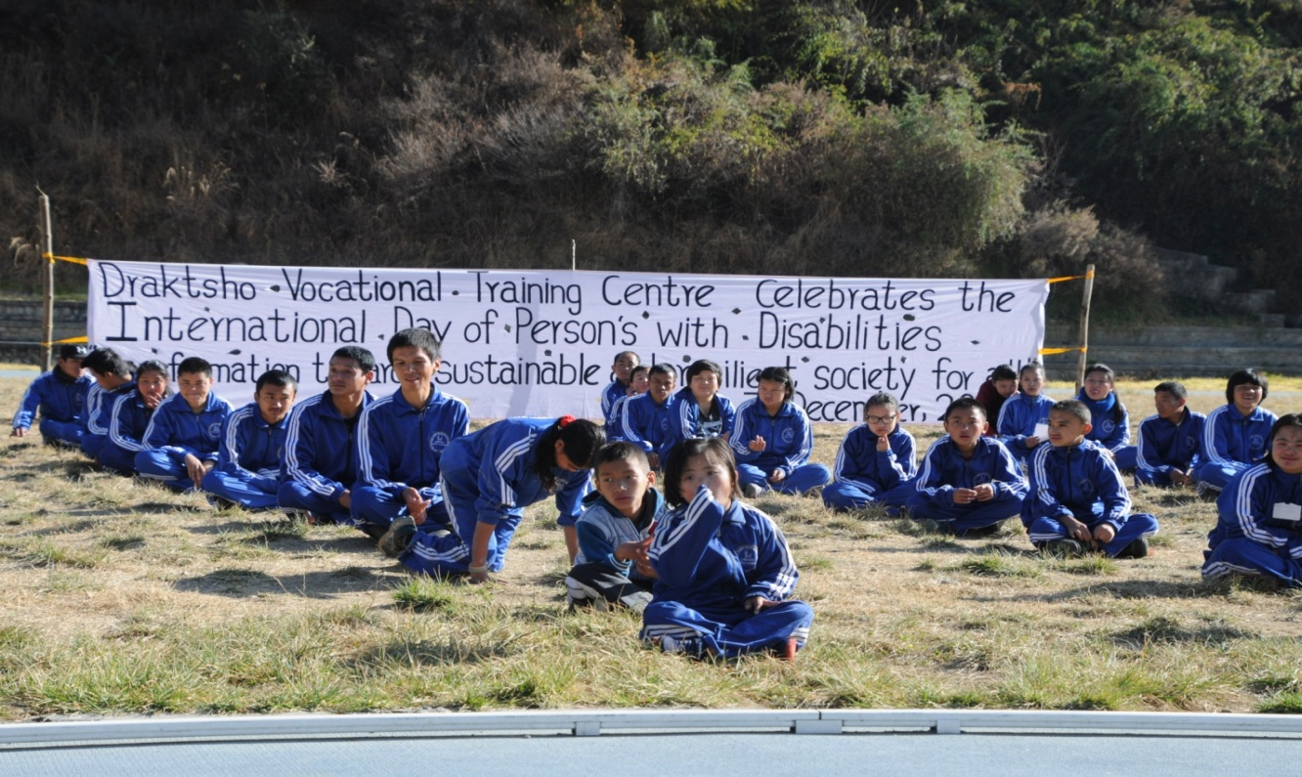
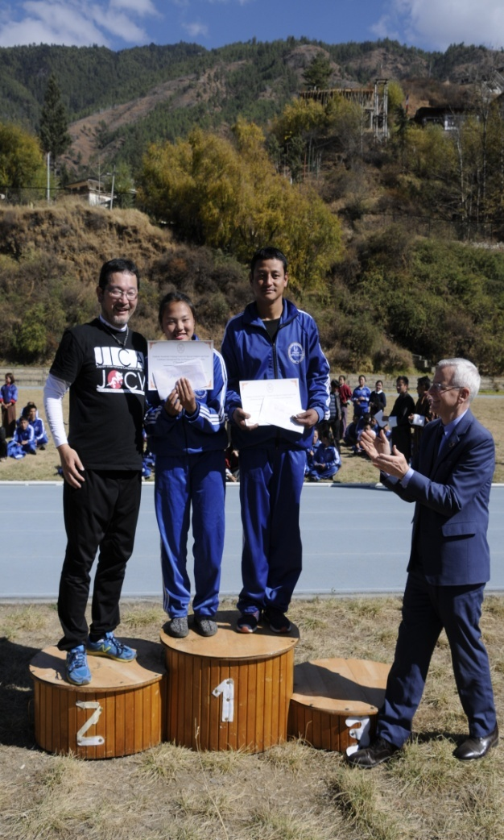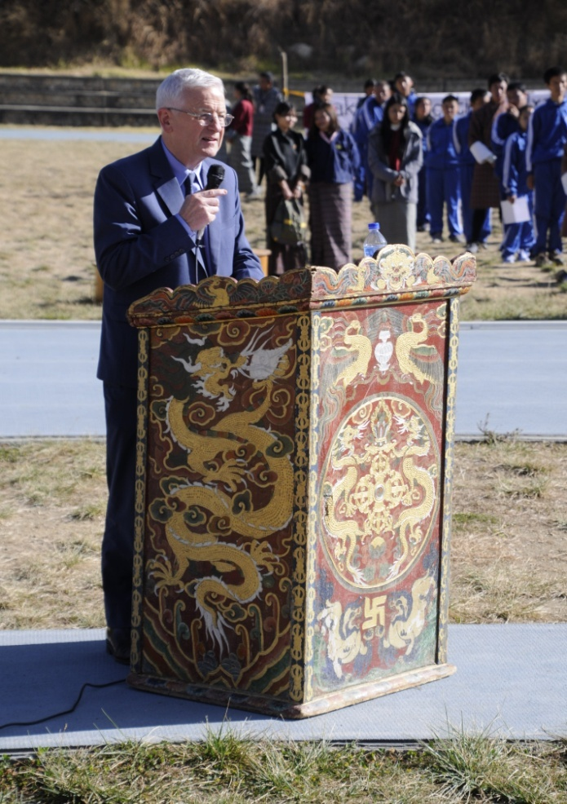
Best male and female athletes of the year, Mr. Pelden(Special Olympic Gold and Silver recipient) and Ms. Tenzin Lhaki receives special awards.

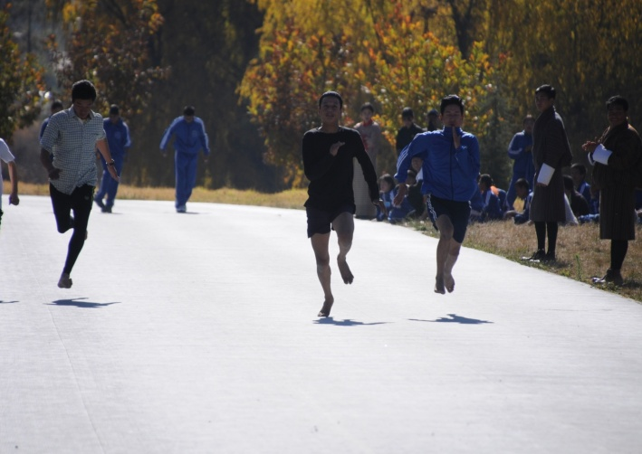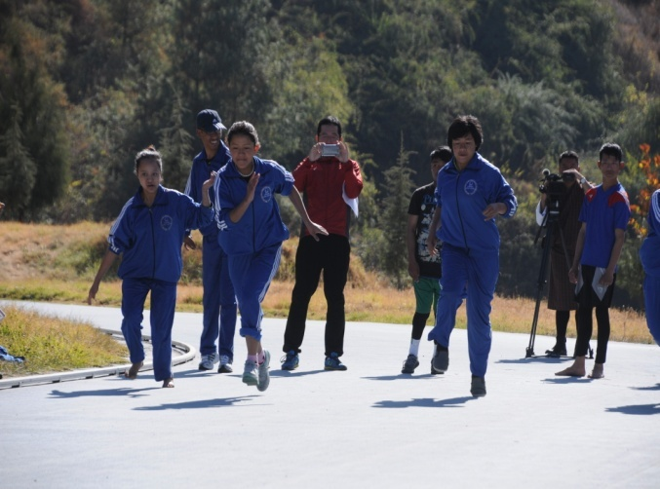

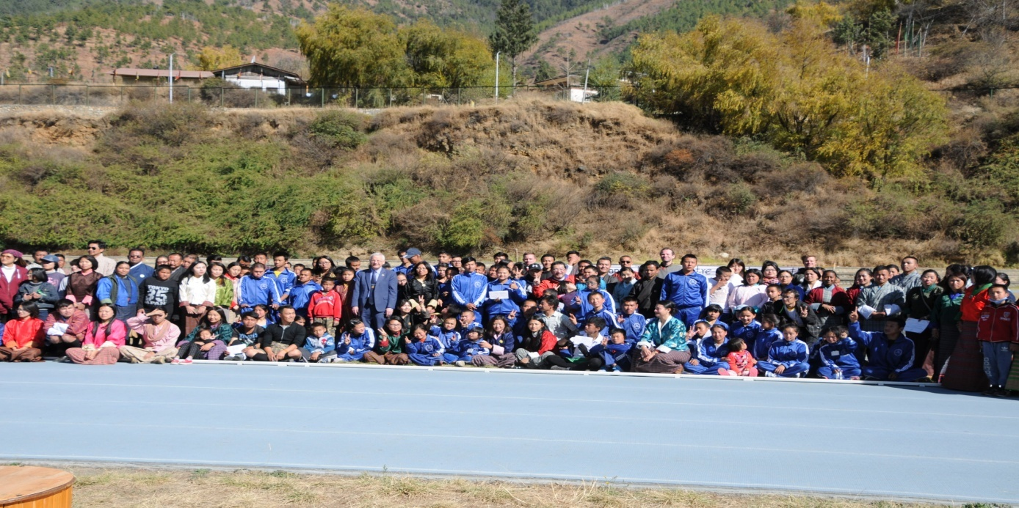

Teacher Training on Special Education
Special Education is one of the core activities of Draktsho as we cater special educational and life skills services to children and youth with all types of disabilities within the age range of 7-35 years. Every morning the students learn basic literacy with focus on three major subjects, English, Mathematics and Dzongkha to enhance their literacy and numeracy skills. Draktsho also has a Early Intervention Unit where children with moderate-severe intellectual disabilities are taught the activities of daily living and other social skills. To impart quality services to the students the teachers must have at least the basic knowledge on Special Education.
Draktsho conducted a Special Education Training for the teachers from 25th-27th December, 2017 at Chuniding Resort in Babesa. There were 25 participants from various organizations such as Opening Your Heart to Bhutan, Disabled Persons Association of Bhutan, Ability Bhutan Society, Bussi-En and teachers of Draktsho. The 3 days training was supported by UNICEF Bhutan. Dr.Pema Wangmo, the first person in Bhutan who has a PhD in Special Education was the instructor for the training.
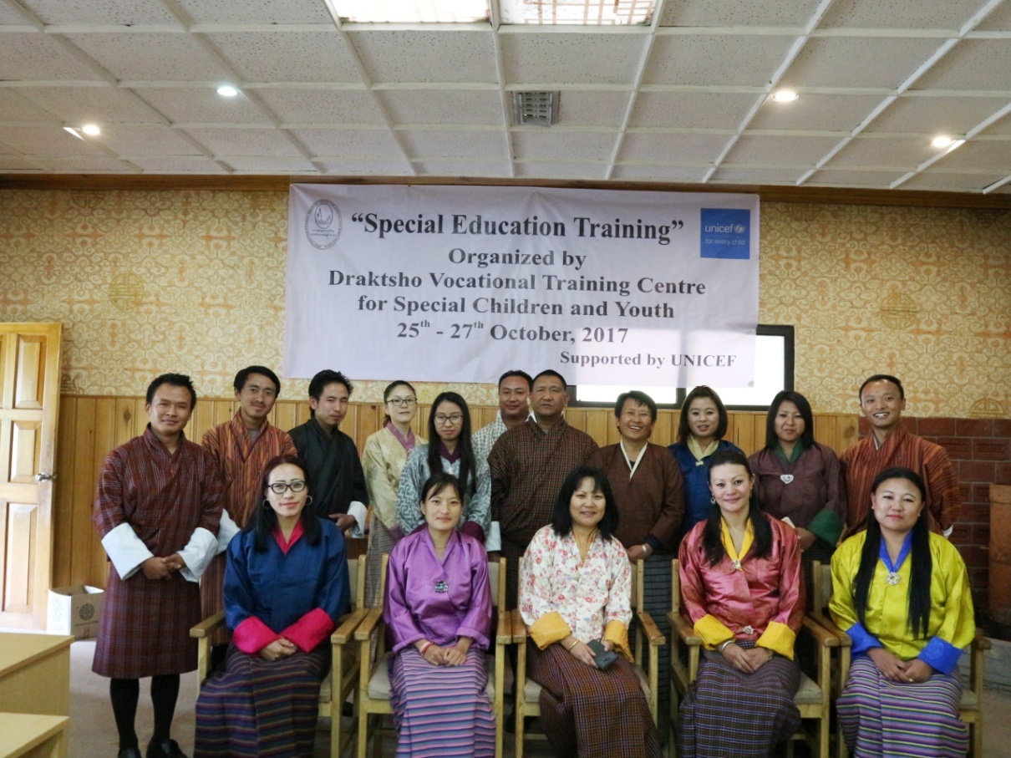

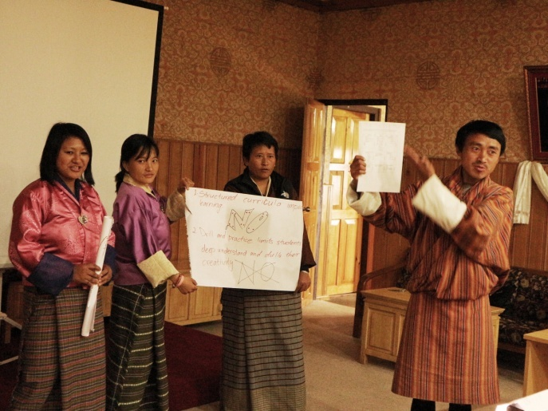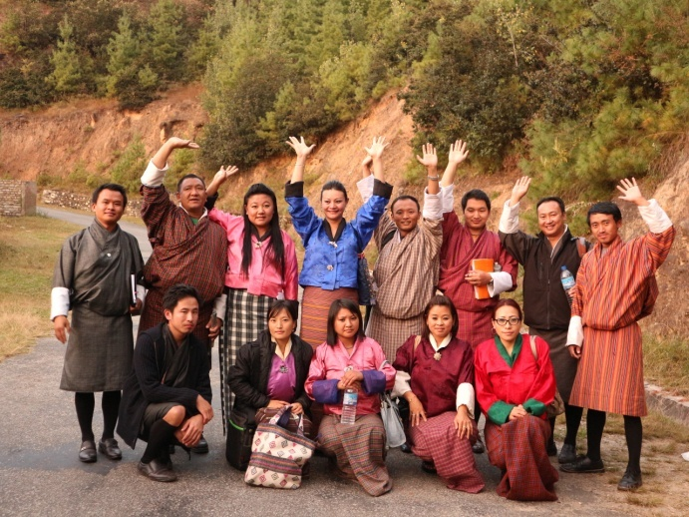

Programs and Activities
Vocational and Co-curricular programs:
The Vocational training and other co-curricular activities given below are some of the training programs offered at the centre. The vocational training is traditional based and which suits the capacities of the students. New skills depending on the requirement of the students are included annually.
Main Vocational Courses offered:
- Tailoring
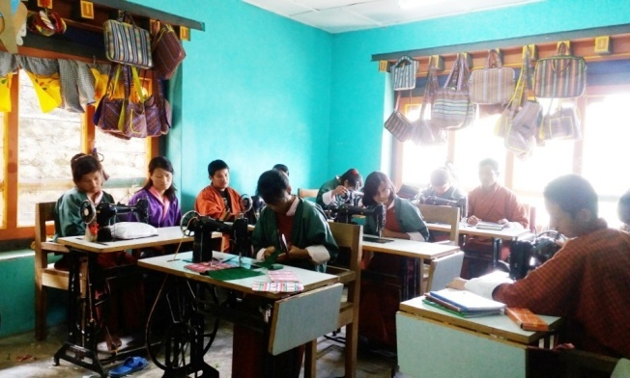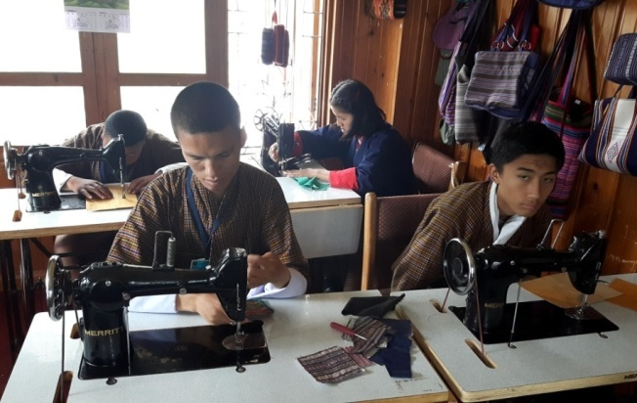
Tailoring course takes 2 to 4 years to graduate; an intellectually challenged may take more years.

- Traditional art and painting
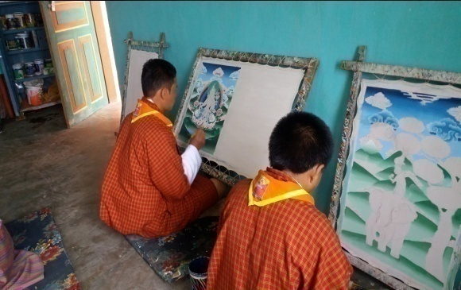
Art and painting takes 5 to 7 years to complete the course, however, it is flexible to allow the students learn at ease.

- Embroidery
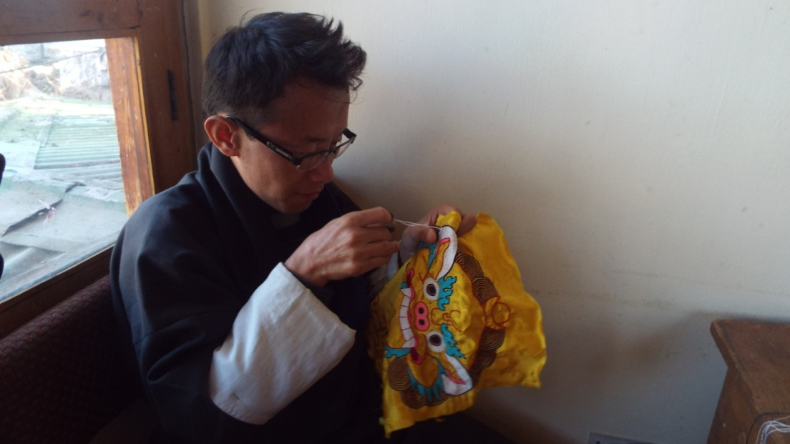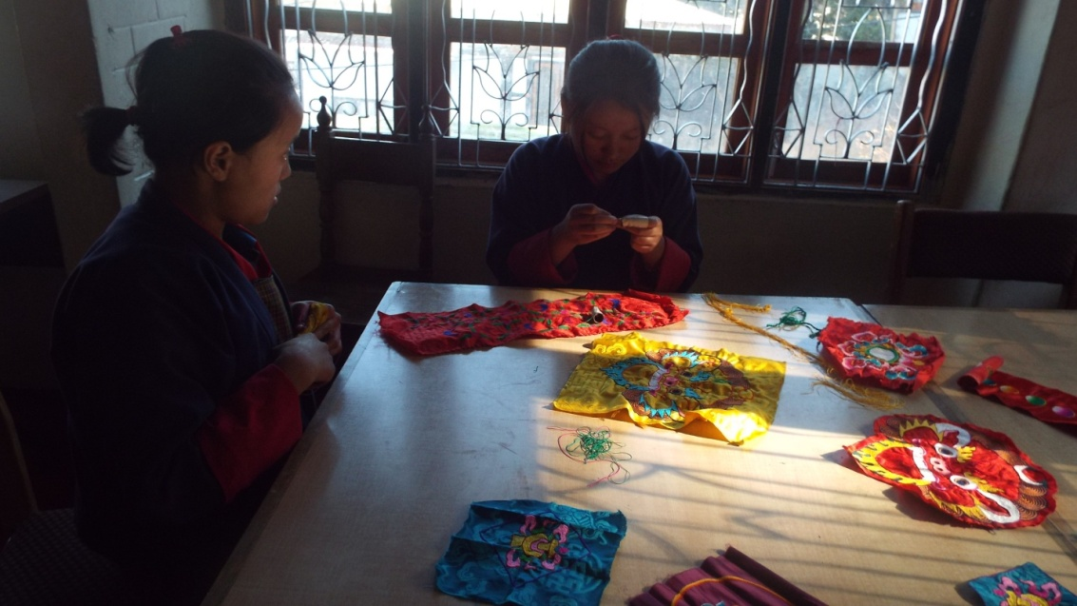
Embroidery is a high level training, it needs good hand eye coordination and good concentration. Most of the students in this class are with hearing and speaking impairment, there are few students with mild intellectual challenges. The course takes 5 to 7 years to graduate.

- Weaving
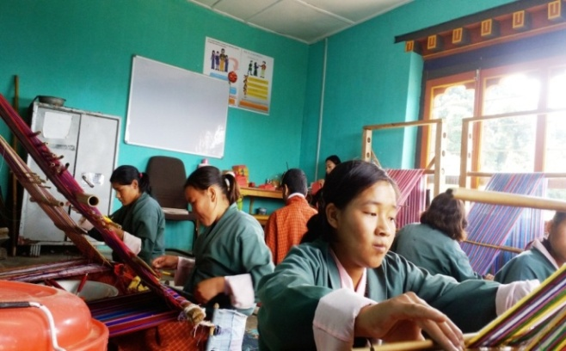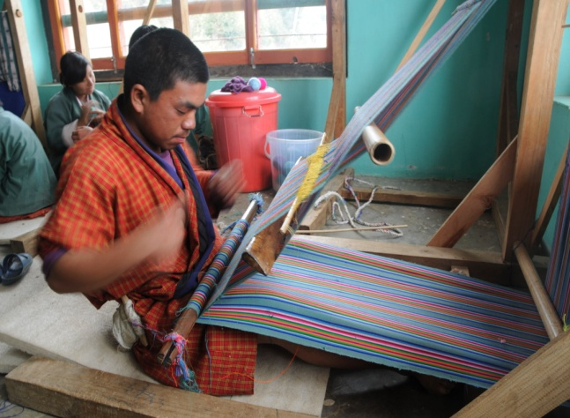
Weaving is an interesting skill development course. There are all types of youth learning weaving as it has several areas of practice. Though it is more suitable for women, men also enjoy weaving. The course takes 3 to 7 years, depending on the level of intelligence and hand coordination skills.

- Basket weaving(cane and plastic)
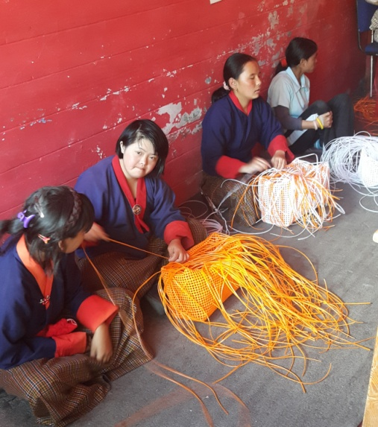
Basket weaving is pre-vocational program for Draktsho. Most of the intellectual students are placed here to determine their motor skills before transferring them to higher level training. Basket weaving develops hand eye coordination, able to sit for a long time in their seats, it also helps control behaviour problem and learn discipline.

- Souvenir carpentry (wood carving)
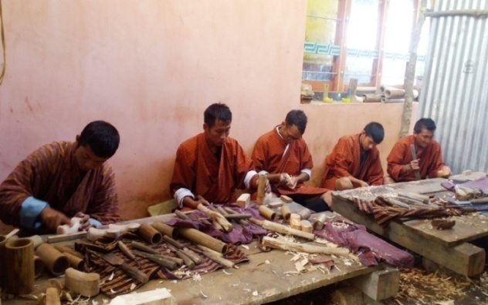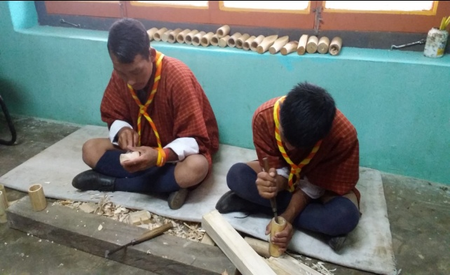
Wood carving require good hand eye coordination, besides learning carving and designing, we make small wooden souvenirs. The period of training is 5-7 years.

- Souvenir making(cards, bookmarks and doll making)
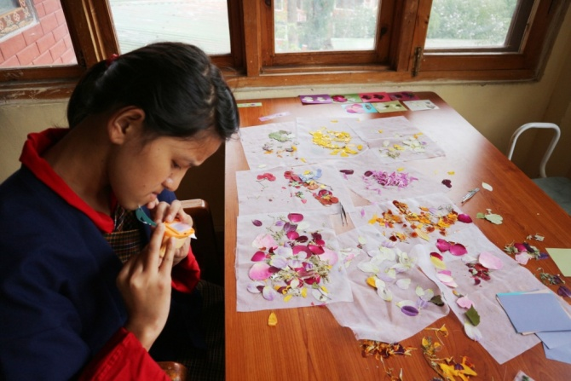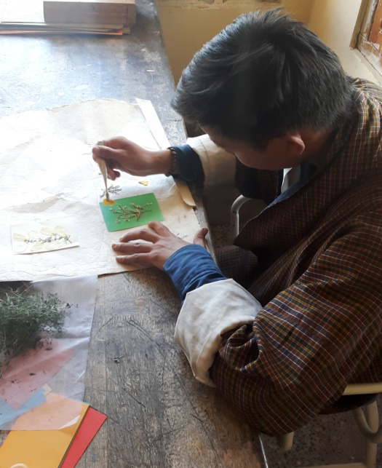
Book marks, Cards, Paper bags and boxes, small dolls are made by youth with mild cerebral palsy students. The training in this area determines the creativity of a student as they design the cards and book marks. It takes 1 to 3 years of training.

- T-Shirt and Mug Printing
The printing training need youth with high level intelligence. We have very few students in this class.

- Envelope Making
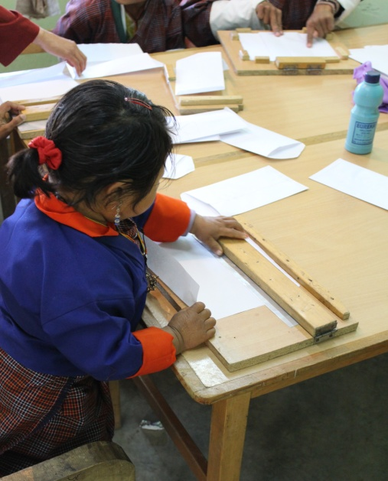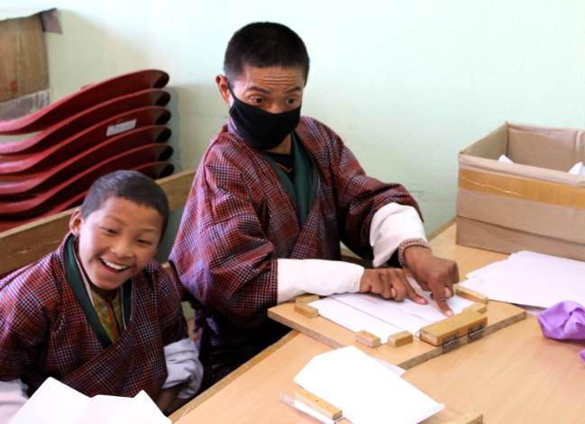
Envelopes are made by youth with moderate IQ level students and physically challenged students. It takes a group of students to complete an envelope as they lack fine motor skills.

- Pottery
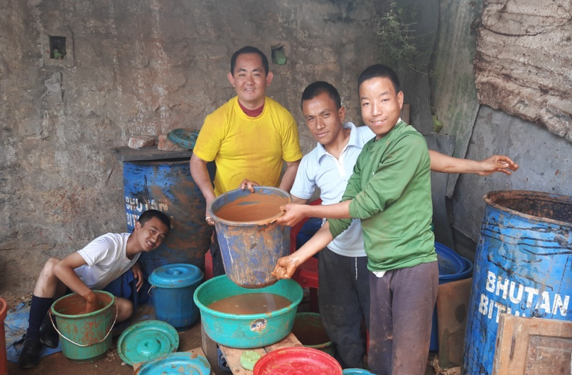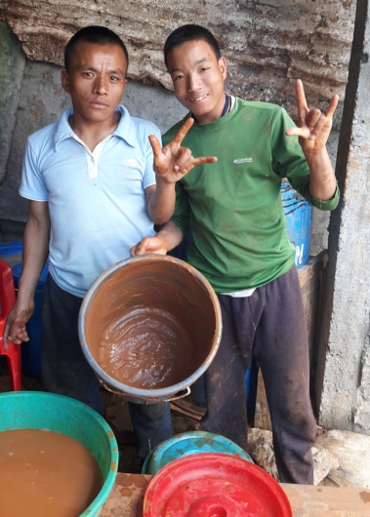
Pottery is a new skill initiated to train severely challenged students. The outcome of this training is yet to determine.
Life skills offered:
- Personal management skills
- Sign language(communication skills)
- Social Behaviour, domestic behaviour
- Work related or Functional Academic
- Safety skills
- Occupational skill and basic education(Special education)
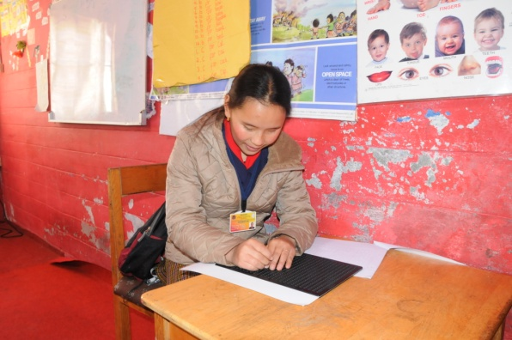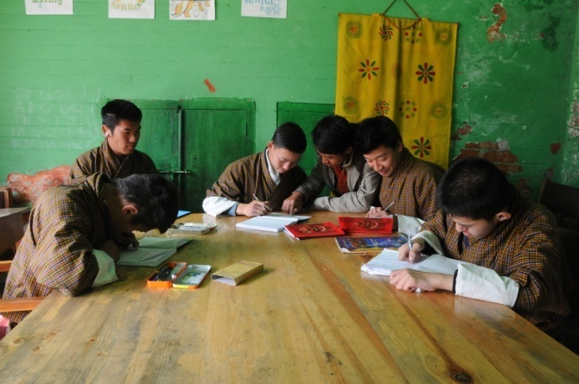
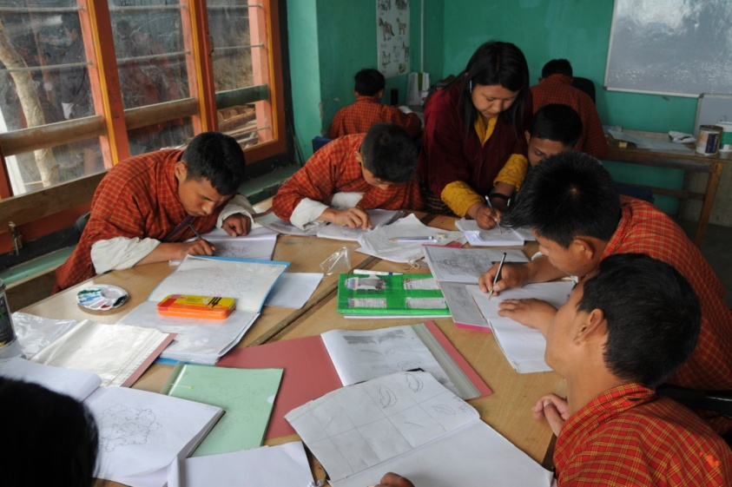
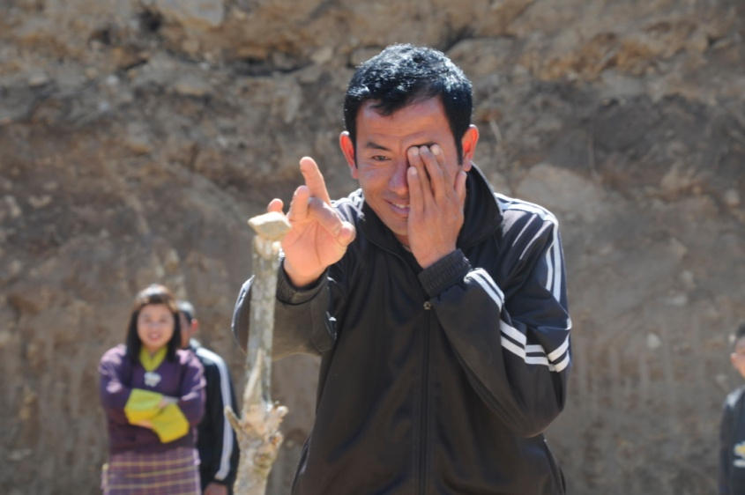

Co-curricular Activities:
- Social skills: dancing, singing, acting and cultural disciplinary programs are taught to the students to built their communication and socialization skills. These activities not only boost's their self esteem but also make them happy and feel inclusive.
- Physical fitness programs: Draktsho is often used as the base for promoting sports for athletes with disabilities as Draktsho has maximum number of children and youth with various types of disabilities. Draktsho organizes a sports competition annually nationwide to promote the Special Olympics movement giving all special athletes a platform to showcase their abilities. This activity not only keeps one fit but brings together everyone experiencing joy, happiness, contentment and victory through inclusion.
The Special Olympics Bhutan which was founded in 2010 by people from different walks of life also operates under the umbrella of Draktsho.
In 2011, 4 athletes (2 boys and 2 girls) participated at the Special Olympics held in Athens, Greece where they participated in track and field events. The athletes won gold in the mixed relay race for the first time. Again in 2015 4 athletes with intellectual disabilities participated at the Special Olympics held in Los Angeles, California. The team brought home 6 medals (3 gold's,2 bronzes and 1 silver) in individual events. They created history in Bhutan by winning that many medals at an Olympic level. They broke barriers proving many wrong and becoming the pride of the nation.
- Apart from the vocational training, educational and life skill program, the students are also given opportunities to development individually through counseling, personal coaching and guidance.
Following one of its long term goals Draktsho has successfully established its first branch in Rongthong ( now shifted to the new premises at Sheningkhar) Tashigang with support from the Finish government. The centre is known as Draktsho East Centre and unlike the centre based in Thimphu it provides boarding facilities to 120 students. The students at Draktsho Thimphu are day scholars and at present there are 200 students (127 boys and 73 girls) in total.

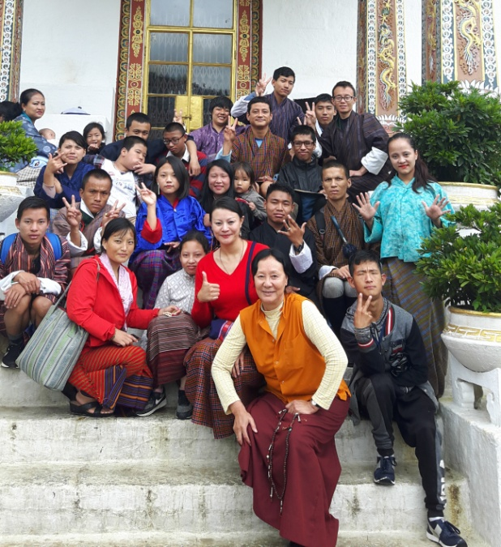
We continue to reach out to the needy and are always looking for avenues to cater our services for all.
Success Stories
- The construction of three one storied buildings(Academic block, boys hostel and girls hostel) at Kanglung,Tashigang was supported by the Embassy of Japan, Embassy of Federal Republic of Germany in Delhi and Opening and Your Heart To Bhutan.
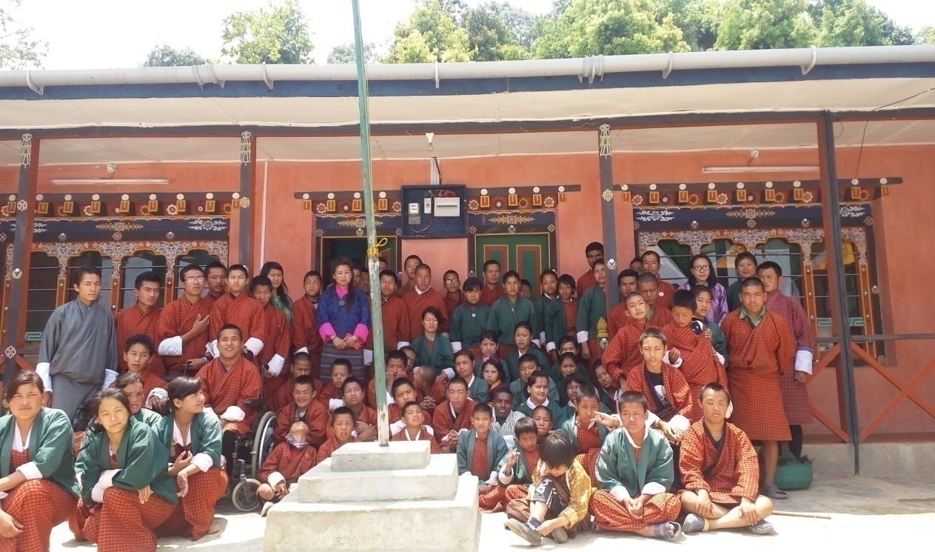

- 12 students graduated this year; they are all employed at the Production Unit of Draktsho. The Ministry of Labour and Human Resources is providing Apprentice Ttraining Program (ATP) support to 12 graduates of Draktsho.
Challenges
Overhead and maintenance cost has always been the biggest challenge for Draktsho. Lack of infrastructure is another major problem.
Our Pledged Donors
In order to reinforce the financial constraint of Draktsho, the following organizations and individuals pledged to support the organization by being "pledged Donors" (In country donors) for Draktsho in 2015. Their contribution and concern to support Draktsho has strengthened its ongoing activities and secured its existence to continue its work well into the future to benefit the children and youth with disabilities in Bhutan. The annual contribution from the pledged donors for the year 2017 are listed below:

Sl | Name | Organization | Contribution
1 | Ashi Sonam Choden Dorji | White Tara Tours | Nu.100,000
2 | Aum Dechen Jamyang & Dasho | Singye Group of Companies | Nu.150,000
3 | Ashi Bidha |  | Nu.00,000
4 | Dasho Sonam Tobgay Dorji and Aum Tashi Pem Jamyang |  | Nu.60,000
5 | Aum Sangay Zam | Proprietor, Rinchen High School | Nu.50,000
6 | Aum Sonam Choden and Mr.Ugyen Wangchuk | Proprietor, Hotel Jumolhari | Nu.40,000
7 | Mr. & Mrs. B B Gurung | Proprietor, 8 Eleven, Thimphu | Nu.5000
9 | Mrs. Kaoru Aoki | Zhidhey Bhutan Tours and Trek | Nu.30,000

Thank You,
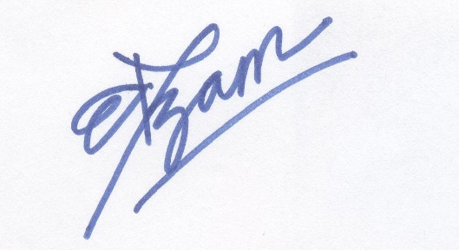
Deki Zam
Exe. Director
Draktsho
Email. dekzang@hotmail.com
Mb: 77273144

